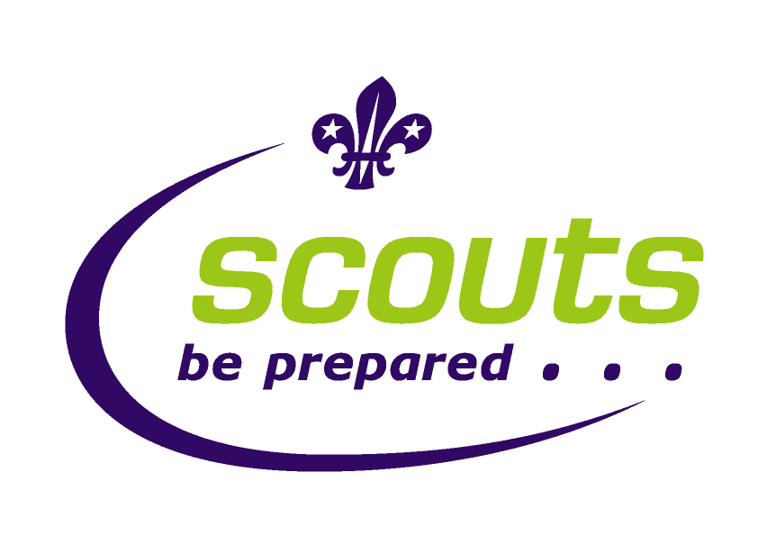
ALL WALES SCOUT CAMP 2012
Royal Welsh Show Ground
Builth Wells 15th – 17th June

Scout permission to camp and health form
This form should be filled in by a parent or guardian.
This information will be kept confidential.
Participant Number : (office use)
Surname: | Forename:
Scout Group: | District:
 | Area:
Date of Birth: | Date of Last Tetanus
Family Doctor’s Name and Address: | Current Medication:  This should be handed to the Group Leader in a clearly marked container.
Please give information of any allergies that your child may have: | Please give information on any health concerns your child may have:
1st Emergency contact number.  Name:  Address & Phone Number : | 2nd Emergency contact number.  Name:  Address & Phone Number:
I herby give permission for my child (details above) to attend the All Wales Scout Camp 2012 and take part in the activities provided. I specifically give consent for my child to be given any over-the-counter medication as deemed necessary by the on-site first aid team. Please provide exceptions to this consent on the reverse of this form.
If it becomes necessary for my child to receive medical treatment & I cannot be contacted, I hereby give my general consent to any necessary medical treatment and authorise Pete Jeffreys, Camp Leader to sign any documentation necessary on my behalf.
Name: | Relationship to child: | Signature:
Please be aware that during this event photographs will be taken, and may be used later for display or promotional purposes, if you do not wish your child to be photographed please attach a letter stating this and a small passport size photograph, (this will be destroyed) so we can recognise your child.

