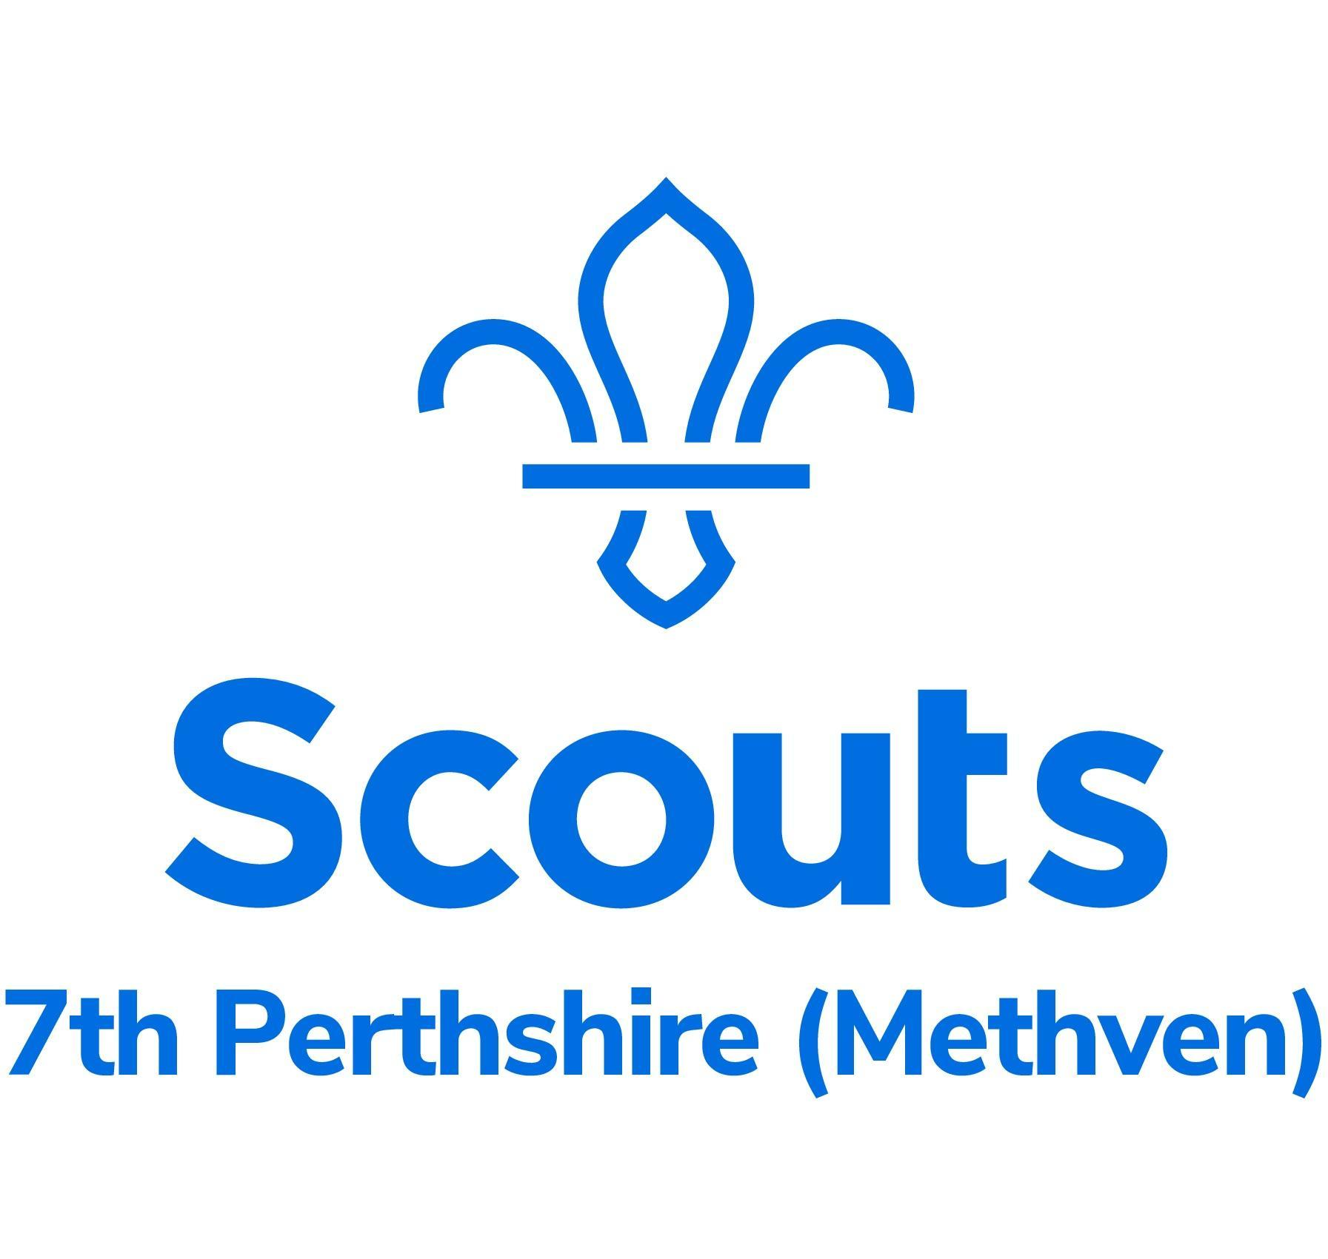**Kit List - Barrwood 2024**

*All young people will need to bring their own personal equipment and should be encouraged to pack themselves.* ***If you do not have any of the items please ask, we can help with most****.*

|  | **Arrive in…** |  | □ | Trousers & shorts (one per day) |
| --- | --- | --- | --- | --- |
| □ | Complete uniform |  | □ | Spare underclothes (one pair per day) |
| □ | Hike boots/ sturdy shoes/ Trainers |  | □ | Spare socks (one pair per day) |
| □ | Warm Jacket |  | □ | Swimwear & clothes to get wet |
|  | **Have to hand…** |  | □ | Nightwear & thick socks |
| □ | **Small Rucksack/Daysack** - with the items below inside |  | □ | A second layer of nightwear e.g. onesie or joggers and jumper |
| □ | Waterproof Jacket |  | □ | Personal washing requirements and a towel |
| □ | Waterproof Trousers |  | □ | Warm Sleeping bag (for outdoor use) |
| □ | Reusable drinks bottle containing water |  | □ | Roll Mat |
| □ | Hat, gloves, scarf/ buff |  | □ | Pillowcase (dry clothes placed inside, as a pillow) |
| □ | Sun hat, sun cream |  | □ | Plate, Bowl & Mug (plastic not crockery), in a bag |
| □ | Any regular medicines - to be given to leaders on arrival (named & clear dosage) |  | □ | Fork & Spoon or spork (in the bag with P/B/M) |
|  | **Pack for later…** |  | □ | Tea Towel (in the bag above) |
| □ | **1 Large Bag** - with the items below inside |  | □ | Personal first aid kit |
| □ | Plastic bags x3 (for dirty clothes) |  | □ | Head Torch |
| □ | Spare trainers (will get wet) |  | □ | Midge repellent, midge net (if you have one) |
| □ | Warm sweater, jumper, fleece or sweatshirt (one per day) |  | □ | Camp blanket (not essential, only if you have one) |
| □ | T-shirts or similar (one per day) |  | □ | Teddy! …just one ☺ |

Please do not bring anything of value or anything that can not get wet.

Please do not bring any food, especially sweets or fizzy drinks, they will be well fed.

**All items must be clearly labelled** with the young person’s name - Thank You!